PENETRATION TESTING LAB REPORT

DOM-Based Cross-Site Scripting (XSS)
PortSwigger Web Security Academy | Apprentice Lab

1. Executive Summary
A DOM-based Cross-Site Scripting (XSS) vulnerability was demonstrated in the PortSwigger Web Security Academy lab, “DOM XSS in document.write sink using source location.search.” The application's client-side JavaScript reads a value from the URL query string and passes it to document.write(). The browser alert confirms JavaScript execution, and PortSwigger confirms that the lab was solved.

2. Lab Information and Scope
Platform: PortSwigger Web Security Academy
Lab: DOM XSS in document.write sink using source location.search
Vulnerability: DOM-based Cross-Site Scripting (XSS)
Difficulty: Apprentice
Source: window.location.search, read using URLSearchParams
Sink: document.write()
Scope: Assigned, intentionally vulnerable PortSwigger lab instance
Testing was restricted to the authorised training environment.

3. Vulnerability Overview
DOM-based XSS occurs when client-side JavaScript processes attacker-controlled data unsafely and passes it to a browser feature that interprets it as HTML or executable content. In this lab, the URL query string is the source and document.write() is the sink. The Burp Suite screenshot shows the search parameter being retrieved with URLSearchParams(window.location.search).get('search') and passed to trackSearch(query), which writes it into the document.

4. Methodology and Findings
- Opened the lab and used the blog search functionality.
- Submitted a search value and inspected the request and response in Burp Suite.
- Inspected the client-side JavaScript. It retrieved the search parameter using URLSearchParams(window.location.search).get('search').
- Identified that the resulting value was passed to trackSearch(query), which writes the value through document.write().
- Observed a browser alert displaying “1”, confirming JavaScript execution.
- Verified the PortSwigger lab completion confirmation.

5. Source-to-Sink Analysis
Source: window.location.search
Parameter extraction: URLSearchParams(window.location.search).get('search')
Processing function: trackSearch(query)
Sink: document.write()
The issue arises because URL-controlled data reaches document.write() without safe handling for the HTML context.

6. Proof of Concept and Result
Observed result: A browser alert displaying “1” appeared. The supplied screenshots establish the source-to-sink flow, successful JavaScript execution and PortSwigger lab completion. The exact final URL or complete payload is not visible in the screenshots, so it is not inferred here.

7. Security Impact
If an application places attacker-controlled URL data into an unsafe DOM sink, an attacker may be able to craft a URL that causes JavaScript to execute when a victim visits the page. Depending on the application and browser-side protections, possible consequences include page manipulation, phishing, access to information available to page scripts, or actions performed through a victim's authenticated session. The lab evidence confirms script execution but does not independently establish each possible impact.

8. Remediation
- Do not pass untrusted URL parameters to document.write().
- Use safe DOM APIs such as textContent when inserting plain text.
- If HTML insertion is necessary, use a maintained allowlist-based sanitiser.
- Validate data for its intended use, while recognising that validation does not replace safe output handling.
- Add security tests for client-side source-to-sink flows.

9. Evidence
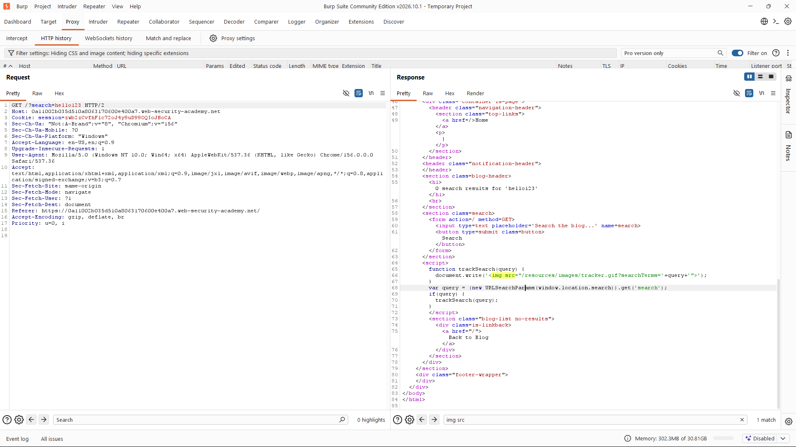
Figure 1. Burp Suite response showing URLSearchParams reading the search parameter and trackSearch(query) passing it to document.write().
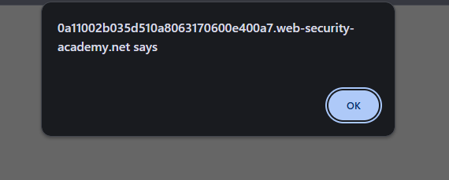
Figure 2. Browser alert displaying 1, confirming JavaScript execution.
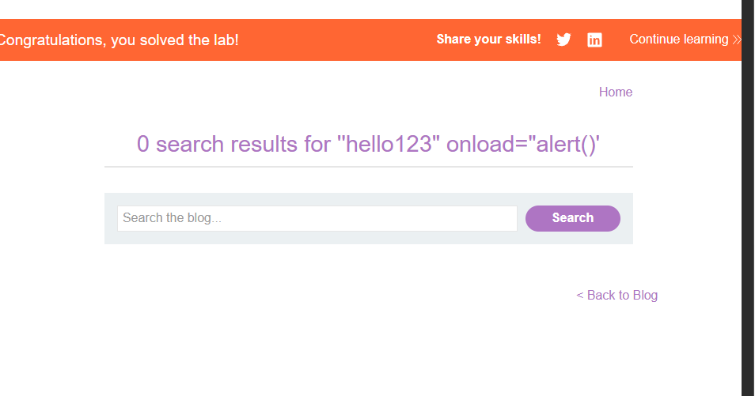
Figure 3. PortSwigger confirmation that the lab was solved.

10. Conclusion
The lab demonstrated DOM-based XSS caused by passing URL-controlled search data to document.write(). JavaScript execution was confirmed by the browser alert, and the platform displayed its solved confirmation. The key defensive lesson is to avoid unsafe DOM sinks for untrusted data and use safe DOM APIs or appropriate sanitisation when HTML insertion is required.

11. Limitations and Reporting Notes
This is a controlled training exercise, not a production-system assessment. The screenshots show the source-to-sink code in the response, a browser alert and the lab completion banner. They do not show the exact final URL or a complete request containing the exploit input.
CVSS: Not assigned. A production severity score requires application-specific context and a justified impact assessment. CVE: None identified or applicable to this deliberately constructed lab.

